**Topic**: Summer Bootcamp on Deep Learning and Applications

**Timeline:** June 3st-14th; Afternoon: 1:00-5:00 pm EST (30 mins break)

1-3:00pm; 3:30-5pm (Lab coding)

Lectures: basic knowledge + lab coding

About lab coding: each instructor needs to prepare coding assignment (Pytorch)

Flyer deadline: March 20th

**Syllabus**:

* Basic deep learning models: Linear regression, MLP, CNN, LSTM, Transformer, LLM, NLP for sentiment (raw data)
* Pytorch tutorial
* Data preprocessing

| Day 1 | Day 2 | Day 3 | Day 4 | Day 5 | Day 6 | Day 7 | Day 8 | Day 9 | Day 10 |
| --- | --- | --- | --- | --- | --- | --- | --- | --- | --- |
| Intro, LR | MLP | CNN  (medical image) | Data prep. (word embedding) | LSTM | Transformer | Constrative learning | Transfer learning | LLM (chatGPT) | AI for cars |
| Pytorch tutorial |  |  |  |  |  |  |  | Release project | Project com |

**Website: GitHub**

Best project award: **certificate**

**Cluster**:

Keynote speakers (foreign):

[1]

[2]

* Questionnaire: race, grade
* Feedback form

Tasks:

* Huajie Shao (website information)
* Minghan Chen (register form+feedback, flyer)
* Aobo: (cluster)
* Mengdi/chenling: slides to Google Drive, recording, schedule
* Huaxiu: advertising (flyer)

Flyer information:

**Title**: Summer Bootcamp on Deep Learning and its Applications

**Date & Time**: June 3rd - 7th, June 10th - 14th, 1:00 - 5:00 pm EST

**Format**: Lecture, Hands-on Lab Sessions, and Invited Talks

Apply from: <https://forms.gle/ak3mU3LQgBfFEG718>

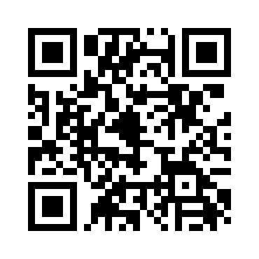

Website: <https://ai-bootcamp2024.github.io/>

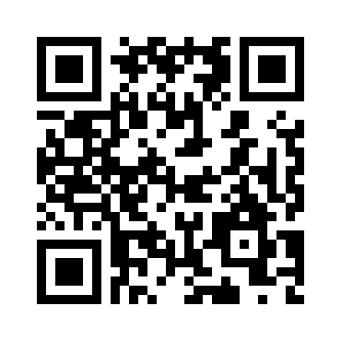

Topics covered:

Deep Learning Basics;

Trending Deep Learning Models (Transformer, Large Language Model, etc.);

Real-World Applications (Health, Autonomous Driving, Astronomy;)

One paragraph summary:

<https://wmcsymp.github.io/>